User Guide

Installing XTractor
Copy the XTractor folder and all its contents to any target directory that shall be referred to as [target].

Launching XTractor
For Windows or Linux users, type the following on the command line:

cd [target]/XTractor
java –jar xtractor.jar

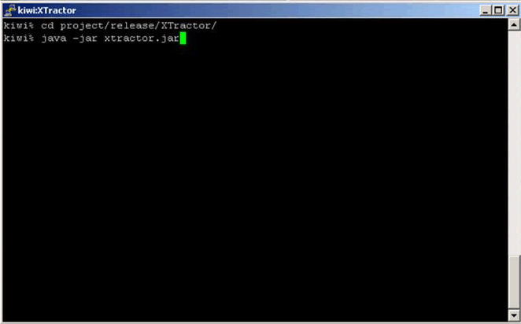

Windows users may alternatively run the application by double-clicking on the xtractor.jar icon.

Tutorial

When the application has been launched, the task selection window appears.
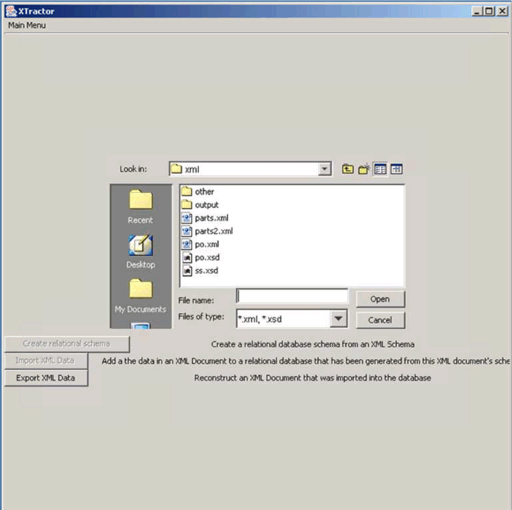

Before starting, a database connection must be configured. Click on the ‘Database Configuration’ button in the menu bar.
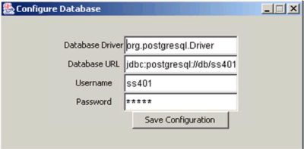

To confirm the changes, click on the ‘Save Configuration’ button. To cancel any changes, close the popup window.

Creating a Relational Schema
Select an XML Schema file from the file chooser. The file must end in ‘.xsd’. If a ‘.xsd’ file has been selected, the ‘Create Relational Schema’ button will become enabled.

Click on this button to obtain a visualization of the XML Schema.
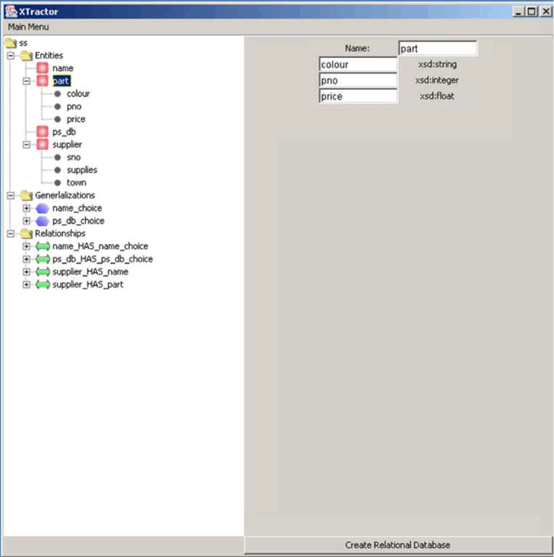

The XML Schema can be modified in the visualization window. As an example, click on the entity named ‘part’. In the text boxes that appear on the right, delete the name ‘part’ and rename it ‘component’. And replace the attribute name ‘price’ with ‘rec_retail_price’.

The XML Schema to SQL datatype mappings can be customized. Click on the ‘Type Mappings’ button in the menu bar. Change the ‘string’ mapping value from ‘VARCHAR(50)’ to ‘VARCHAR(40)’.

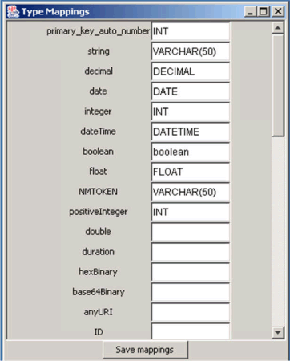

Click on the ‘Save Mappings’ button to confirm the changes. To cancel the changes, close the window.

Click on the ‘Create Relational Database’ button in the bottom right hand corner to proceed with the schema creation.

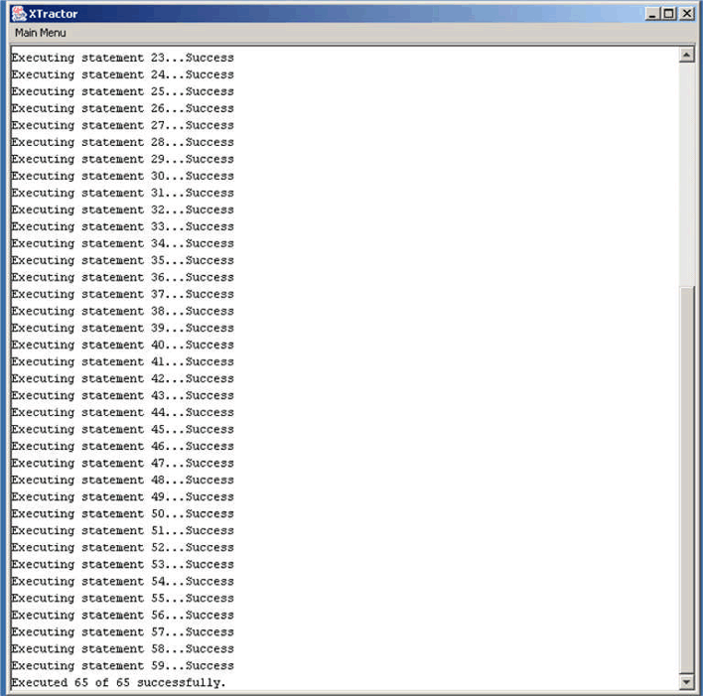

When the dialog reports “Executed m out of n successfully”, return to the Task Selection window by clicking the ‘Main Menu’ button in the menu bar.

Importing XML Data
From the file chooser, select an XML file whose data you wish to import. If a ‘.xml’ file has been selected, the ‘Import Data’ button should become enabled.

Click on the ‘Import Data’ button to proceed. A window will appear prompting you to select the relational schema you wish to import the data into.

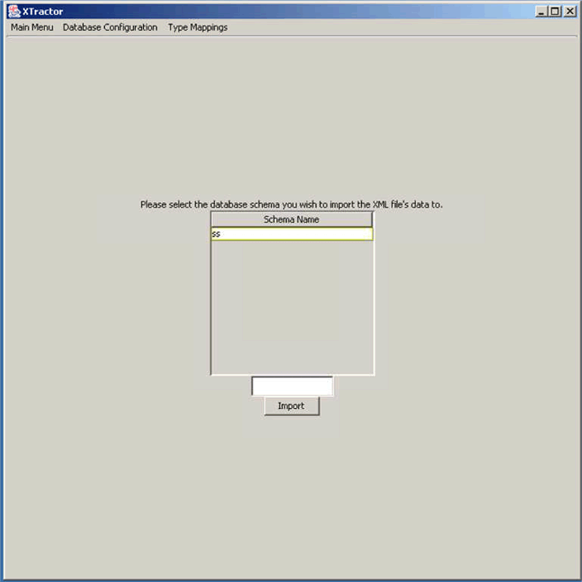

When a schema has been selected, it should appear in the text field below. To begin importing the XML document’s data into the selected relational schema, click the ‘Import’ button. A dialog window similar to that encountered during relational schema creation will appear.

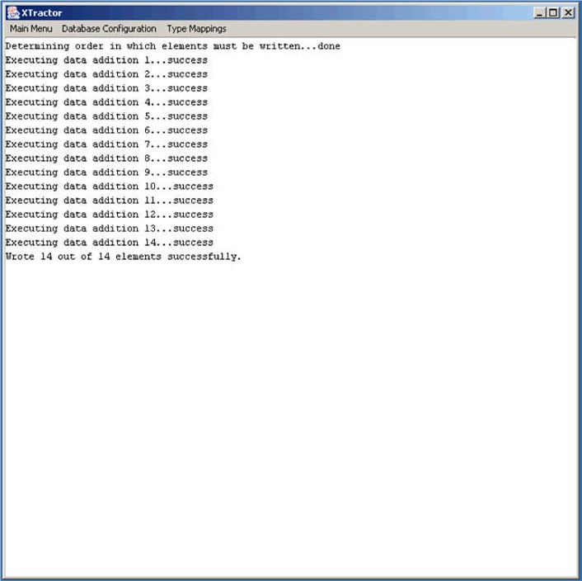

When the dialog reports ‘Wrote m out of n elements successfully’, return to the main menu.

Regenerating an XML file

From the Task Selection window, click on the ‘Export Data’ button. Select the relational schema from which you wish to export data and click the ‘Export Data’ button. A window prompting you to select a document to regenerate will appear.
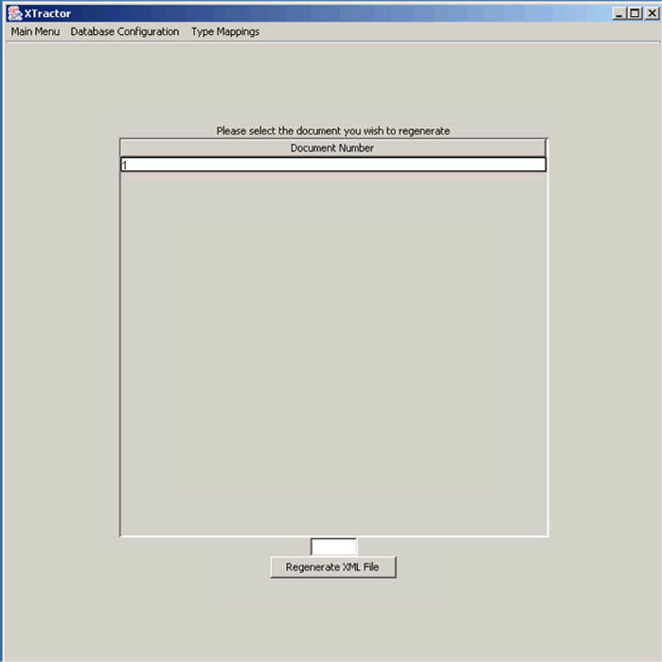

Select the document you wish to regenerate. Click the ‘Regenerate XML File’ button to begin the reconstruction process.

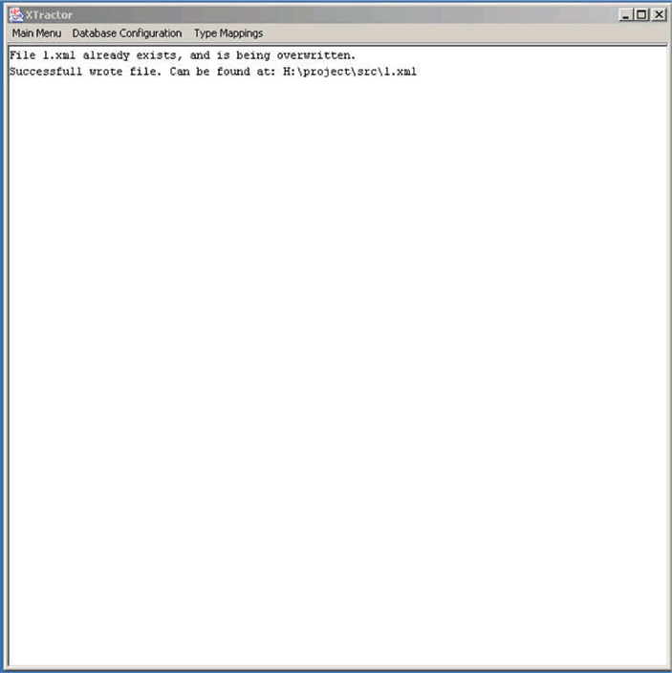
When the dialog window reports ‘Successfully wrote file’, the file has been created. It can be found at the location the dialog window specifies.

